**Software Requirements Specification (SRS) Document**

**Shellkart – One Stop Solution** **To Buy Every Shell Product**



**1. Challenges Faced/ Can Be Solved**

**1.1 Infrastructure Challenges**

* **Challenge:** Setting up robust and scalable server infrastructure for handling high website traffic.
* **Solution:** Utilize cloud services (e.g., AWS, Azure) to ensure scalability and performance optimization.

**1.2 Security Challenges**

* **Challenge:** Ensuring the security of user data, payment information, and the website as a whole.
* **Solution:** Implement encryption (SSL/TLS), firewall, and regular security audits. Comply with relevant data protection laws.

**1.3 Payment Gateway Integration**

* **Challenge:** Integrating secure payment gateways to facilitate online transactions.
* **Solution:** Use reputable payment gateways (e.g., PayPal, Stripe) with robust APIs for secure payment processing.

**1.4 Inventory Management**

* **Challenge:** Managing and updating product inventory in real-time.
* **Solution:** Implement a real-time inventory management system integrated with the website.

**1.5 User Experience Enhancement**

* **Challenge:** Improving the overall user experience to increase sales and customer satisfaction.
* **Solution:** Conduct user testing, gather feedback, and continuously iterate on the website's design and usability.

**1.6 Mobile Responsiveness**

* **Challenge:** Ensuring the website is responsive and user-friendly on various devices.
* **Solution:** Utilize responsive web design principles to adapt to different screen sizes.

**1.7 Performance Optimization**

* **Challenge:** Ensuring fast page loading times, especially for high-resolution product images.
* **Solution:** Implement content delivery networks (CDNs) and image compression techniques.

**1.8 SEO and Marketing**

* **Challenge:** Increasing the visibility of Shellkart on search engines and attracting more customers.
* **Solution:** Implement SEO best practices, content marketing, and social media integration.

**2. Scope**

Shellkart, the forthcoming e-commerce venture by Shell India Markets Pvt. Limited, is poised to emerge as a comprehensive platform for retailing an extensive assortment of Shell products, encompassing lubricants, fuels, and automotive merchandise. Rooted in the commitment to customer satisfaction, Shellkart is dedicated to delivering an impeccably user-friendly, secure, and streamlined shopping experience. This online marketplace will not only offer a diverse product portfolio but also prioritize the safety and convenience of its patrons, ensuring that they can effortlessly access and procure Shell's high-quality offerings while enjoying a seamless and trustworthy digital retail environment.

**3. Functional and Non-Functional Requirements**

**3.1 Functional Requirements**

* User Registration and Authentication
* Product Catalog and Search
* Shopping Cart Management
* Payment Gateway Integration
* Order Processing and Tracking
* User Reviews and Ratings
* Admin Dashboard for Product Management
* Inventory Management
* User Account Management
* Customer Support Chat
* Reporting and Analytics

**3.2 Non-Functional Requirements**

* Security and Data Protection
* Performance and Scalability
* Mobile Responsiveness
* SEO Optimization
* Compliance with Regulatory Standards
* Backup and Disaster Recovery
* Usability and User Experience

**4. Users Use Case Diagram**

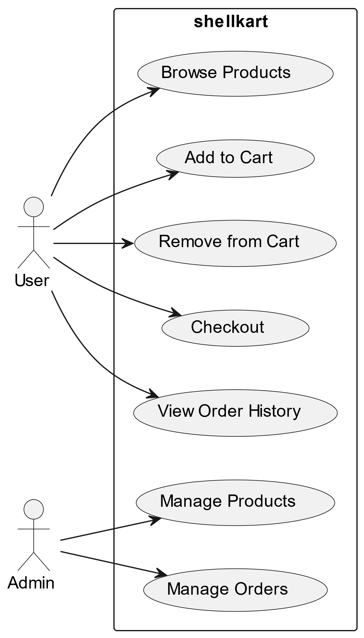

**5. Entities and Their Properties and Data Types**

**5.1 User Entity**

* User ID (int)
* Username (string)
* Email (string)
* Password (string)
* Shipping Address (string)
* Payment Information (encrypted)
* Role (e.g., customer, admin)

**5.2 Product Entity**

* Product ID (int)
* Product Name (string)
* Description (text)
* Category (string)
* Price (decimal)
* Quantity (int)
* Image (URL)
* Rating (float)

**5.3 Order Entity**

* Order ID (int)
* User ID (int)
* Order Date (datetime)
* Status (e.g., pending, shipped, delivered)
* Total Amount (decimal)

**6. Database and ER Diagram**

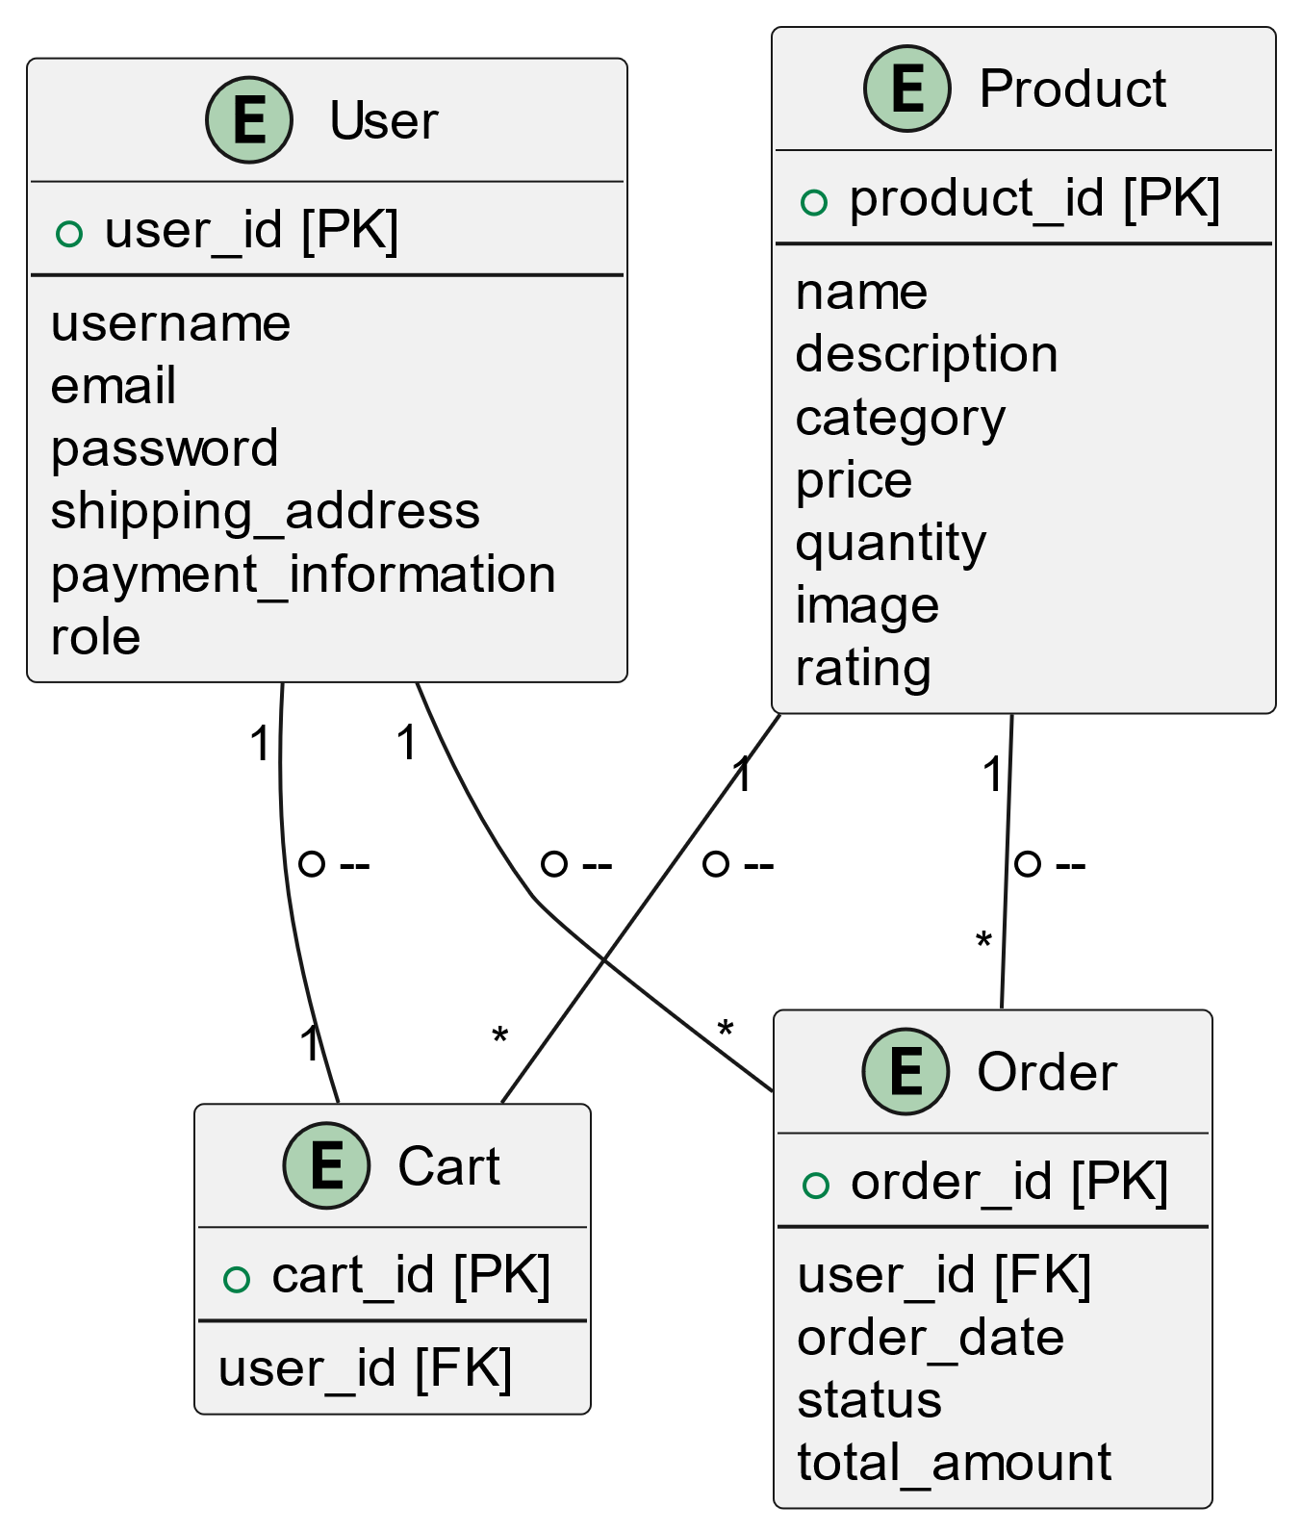

**7. Sequence Diagram**

